Cost effectiveness analysis of Cabazitaxel plus Prednisone versus Mitoxantrone plus Prednisone in metastatic castration-resistant prostate cancer after Docetaxel failure
A UK NHS perspective

Advanced health economic modelling

Aida van Riel
Anna
Irma
Sanya

March 2024

AI statement: We used AI to solve the technical issue we had with running the PSA. We also used it to support spelling correction of the written text.

Word count: 9,709 (appendix, reference and tables excluded)

INDEX
INDEX 2
METHODS 5
FRAMING 5
THE TREATMENT EFFECT 8
RESOURCES USE AND COSTS 15
SENSITIVITY ANALYSIS 27
RESULTS 30
BASE-CASE DETERMINISTIC RESULTS 30
PROBABILISTIC SENSITIVITY ANALYSIS RESULTS 33
SCENARIO ANALYSES RESULTS 35
KEY MODELLING CHOICES AND ASSUMPTIONS 36
APPENDIX 38
APPENDIX A – Survival curve fitting 38
APPENDIX B – Sources of resources use and costs 40
APPENDIX C – Sensitivity analysis 42
REFERENCES 46

INTRODUCTION
Prostate cancer is one of the most diagnosed cancers in men in the United Kingdom, with approximately 55,300 new cases each year (Cancer Research UK, 2023). It accounts for 28% of all male cancer diagnoses and it is the third most common cause of cancer death in the UK, responsible for around 12,200 deaths annually (Cancer Research UK, 2023). The risk of developing prostate cancer increases substantially with age, with most diagnoses occurring in men over 50 years (James et al., 2024). Although overall survival has improved considerably in recent decades, with approximately 79% of patients now surviving ten years or more after diagnosis, outcomes for men with advanced-stage disease remain poor (Cancer Research UK, 2023; James et al., 2024).
For many patients, prostate cancer is initially confined to the prostate gland and can be treated with curative intent through surgery or radiotherapy (Cornford et al., 2021). However, a proportion of patients is present with or eventually develop metastatic disease, in which cancer cells spread beyond the prostate to distant sites, most commonly bones and lymph nodes, often causing symptoms such as back, hip, or pelvis pain (Cornford et al., 2021; De Bono et al, 2010). Once the disease becomes metastatic, cure is generally no longer possible, and treatment focuses on controlling tumour growth and managing symptoms. The standard first-line treatment at this stage is androgen deprivation therapy (ADT), which reduces testosterone levels to slow tumour growth (Cornford et al., 2021). Although ADT is initially effective in most patients, the disease typically adapts over time and continues to progress despite very low testosterone levels. This stage is known as metastatic castration-resistant prostate cancer (mCRPC), meaning the cancer progresses even though testosterone is suppressed to castrate levels (De Bono et al., 2010).
Docetaxel was the first chemotherapy to demonstrate an overall survival benefit in mCRPC and became the standard first-line chemotherapy in this setting (De Bono et al., 2010). However, most patients eventually experience disease progression during or after Docetaxel treatment, creating an urgent need for effective second-line options. Before Cabazitaxel became available, the main second-line treatment was Mitoxantrone plus Prednisone. Although Mitoxantrone provided symptomatic relief and improved pain control, it did not demonstrate a survival benefit compared to supportive care alone (De Bono et al., 2010). This means that while a second-line chemotherapy option existed, none had demonstrated the ability to extend survival in patients progressing after Docetaxel. The urgency of this unmet need has been reflected in public consultations for other mCRPC treatments, in which patients and their families submitted hundreds of letters to the National institute for Health and Care Excellence (NICE) emphasising that any treatment capable of extending life, even by a few months, is of critical importance to this patient population (NICE, 2012)
Cabazitaxel is a taxane-based chemotherapy specifically developed to overcome resistance to Docetaxel. Its efficacy was established in the phase III TROPIC trial, which randomised 755 men with mCRPC progressing after Docetaxel to receive either Cabazitaxel plus Prednisone or Mitoxantrone plus Prednisone (De Bono et al., 2010). Cabazitaxel significantly improved median overall survival compared to Mitoxantrone (15.1 months vs. 12.7 months), corresponding to a 30% reduction in the risk of death. Progression-free survival and tumour response rates were also superior in the Cabazitaxel group (De Bono et al., 2010). A follow-up of the TROPIC trial, analysing the long-term outcomes, demonstrated that a greater proportion of patients treated with Cabazitaxel were alive after two years compared to Mitoxantrone (15.9% vs. 8.2%) and that pain control and functional status were maintained during treatment (Bahl et al., 2013). These findings established Cabazitaxel as the first second-line chemotherapy to provide a survival benefit in mCRPC after docetaxel failure.
Despite this clinically meaningful survival benefit, Cabazitaxel comes at a substantially higher list price than Mitoxantrone and it is associated with more frequent severe adverse events (AEs) that may require additional healthcare resources (De Bono et al., 2010). Although the actual procurement prices paid by the NHS are lower than the list prices, the total treatment costs of Cabazitaxel remain higher due to additional premedication, administration, and healthcare resource use requirements. Given that Cabazitaxel is associated with both higher drug costs and higher resource use, the question arises whether the additional health benefits justify these higher costs.
Within the National Health Service (NHS), healthcare budgets are finite, and resources allocated to one treatment are no longer available for other patients and interventions. Decision-makers therefore need to evaluate not only whether a treatment is clinically effective, but also whether its additional health benefits justify its additional costs. A cost-utility analysis (CUA) provides a structured framework for this comparison by quantifying the trade-off between incremental costs and incremental health outcomes, typically expressed as an incremental cost-effectiveness ratio (ICER) in terms of cost per quality-adjusted life year (QALY) gained (Drummond et al., 2015).
To date, no independent cost-effectiveness analysis of Cabazitaxel versus Mitoxantrone has been conducted from the NHS perspective. Given the substantial cost difference between the two treatments and the clinical significance of the survival benefit demonstrated in the TROPIC trial, there is a clear need for a transparent economic evaluation to inform reimbursement decisions. The aim of this study therefore is to answer the following research question:
“Is the second-line chemotherapy Cabazitaxel plus Prednisone, in metastatic castration-resistant prostate cancer, that has progressed following or during docetaxel-based treatment, cost-effective opposed to chemotherapy Mitoxantrone plus prednisone in the UK?”

METHODS

FRAMING
Perspective
Given that the audience for the cost-effectiveness study is NICE - the agency in the UK that makes recommendations on the use of drugs within the NHS - their guidance regarding the relevant perspective should be followed. Hence this study is done from a healthcare perspective (NHS), where the focus is on costs for the health care provider. Non-medical costs and productivity losses are ignored.

Time-horizon
Given the audience, NICE’s guidance regarding the relevant time horizon should be followed, i.e. a time horizon long enough to include all relevant costs and effects. Therefore, this study is conducted over a lifetime horizon, which should be long enough to cover time to death for most patients. Given the median survival time of approximately 15 months (De Bono et al., 2010) and that at 30 months at least 10-15% of patients is still alive (Bahl et al., 2010), simulating the model for 15 years is considered more than sufficient, as by that point virtually all patients in the model have died.

Population
The target population for the intervention are men (in the UK) who have hormone refractory metastatic prostate cancer, that has progressed following or during Docetaxel-based treatment.

Intervention
The intervention is Cabazitaxel (Jevtana, manufacturer Sanofi-aventis) in combination with Prednisone. The individuals receive 10 mg of oral Prednisone daily and 25 mg/ m² Cabazitaxel on day one of each 21-day cycle. Cabazitaxel is administered intravenously (via IV) over 1 hour. The intervention is continued for a maximum of ten cycles.

Comparator
The comparator is the standard clinical practice for second line treatment in patients with mCRPC in the UK. This involves Mitoxantrone in combination with Prednisone. The individuals receive 10 mg of oral Prednisone daily and 12 mg/ m² Mitoxantrone on day one of each 21-day cycle. Mitoxantrone is administered intravenously (via IV) over 15-30 minutes. The comparator is continued for a maximum of ten cycles, to minimise the risk of Mitoxantrone-induced cardiac toxicity, while ensuring comparable exposure to the treatment and a similar evaluation schedule (De Bono et al., 2010).

Outcome used
This study will be conducted as a Cost-utility analysis (CUA), with the outcome reported as an ICER. CUA is a requirement of NICE with health outcomes measured in QALYs and resource costs and savings taken from the perspective of the NHS and personal social services (NICE guidelines). The ICER reflects the ratio of the incremental cost to incremental QALYs compared to the comparator (here Mitoxantrone) and can be used as an informative measure to judge cost-effectiveness (NICE, 2023; Drummond et al., 2015). QALYs were calculated by combining survival estimates from the TROPIC trial (De Bono et al., 2010; Bahl et al.,2013) with utility values derived from the UK Early Access Programme (EAP) (Bahl et al., 2015), as described in the HRQoL section.
The inputs for the model are as follows:
- Overall survival (OS);
- Progression-free survival (PFS);
- Adverse effects of treatment (These were graded against National Cancer Institute Common Terminology Criteria (NCICTC) for Adverse events. Further details can be found in Table 4 of De Bono et al. (2010));
- Health-related quality of life (HRQoL)

Why a model is needed
A model is needed since the TROPIC trial does not capture lifetime outcomes. The follow-up is too short, because it does not cover the time till death for most patients. Modelling allows for extrapolation beyond the observed follow-up and facilitates the integration of clinical, utility and cost data over time.
A partitioned survival model is used, which is common in oncology and is suitable for the disease we are examining. This model is used as it allows the use of the OS and PFS curves to inform state-membership. Published Kaplan Meier (KM) data with these survival probabilities are available. The Markov model could have similar health states but requires access to patient-level data to estimate transition probabilities, which is not available for this disease.

Model structure
The model consists of three mutually exclusive and collectively exhaustive health states: stable disease (SD), progressive disease (PD) and death. In this model there is only one direction of transitions (see Figure 1). It is assumed that all patients leaving the SD state must first pass through PD before dying; no direct transition from SD to death is possible. Patients can also remain in SD. Patients in the PD health state can remain in this state or transition to death. Patients in the death state remain there permanently. The number of newly progressed and newly deceased patients per cycle was tracked separately, as these counts were needed to apply one-off costs at the point of progression and death, as described in the treatment effect and resource use sections.
The cycle length of the model is 3 weeks, to reflect the standard follow-up and the clinical treatment. As already discussed in the time horizon section, the model simulates until the full cohort has died (lifetime horizon).
AE costs and QALY losses are incorporated as a lumpsum at the start of the model. For simplicity, AEs associated with post-second line chemotherapy in the PD state are ignored. Parameter uncertainty is incorporated through a probabilistic sensitivity analysis, as described in the sensitivity analysis section.

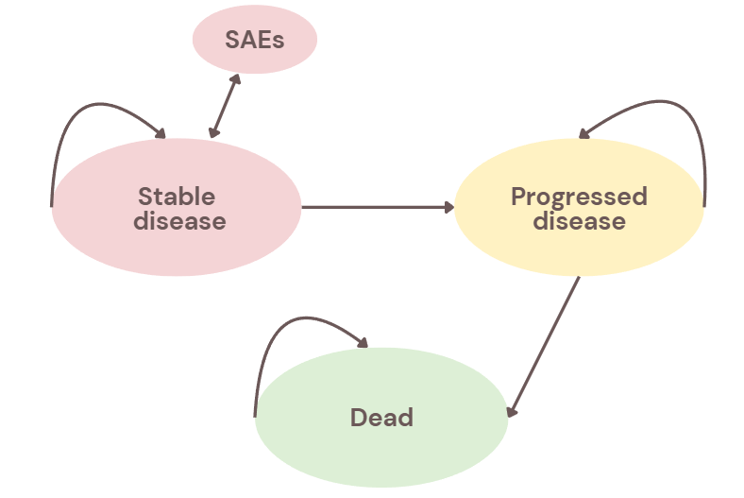
Figure 1. Diagrammatical representation of the model structure
Note: SAEs = Serious adverse events

THE TREATMENT EFFECT
The aim of this study is to evaluate the cost-effectiveness of Cabazitaxel compared to Mitoxantrone. Since the follow-up of the TROPIC trial was not long enough to capture lifetime outcomes, a parametric survival analysis was conducted to extrapolate the overall survival and progression free survival beyond the data provided by De Bono et al. (2010) and Bahl et al. (2013).

The data for the primary endpoint, OS, was derived from the paper by Bahl et al. (2013). This paper was chosen over Bono et al. (2010) because of a longer follow-up period, extending to 2 years or longer compared to a maximum of 2 years in De Bono et al. (2010). This longer follow-up resulted in less censoring and more patients at risk in the tail of the curve, providing a more reliable basis for extrapolation. OS was operationalised as the time of randomisation until the death of the patient and presented in a Kaplan-Meier curve (Bahl et al., 2013)

The data for the secondary endpoint, PFS, was derived from De Bono et al. (2010), as this endpoint was not reported in Bahl et al. (2013). This endpoint encompasses important data for our extrapolation, as we need to distinguish between the progressed and progression-free health states in the partitioned survival model. PFS was operationalised as the time of randomisation until the time of progression and was also presented as a KM curve (De Bono et al., 2010).

To inform our economic model, the published KM curves in both papers had to be extracted and converted into parametric survival functions to allow us to extrapolate the data beyond the trial period. Because individual patient data (IPD) was not available, we had to reconstruct this data to perform our survival analysis. The method used for this is based on the paper by Hoyle & Henley (2011), who demonstrated that fitting parametric curves directly to published KM curves without reconstructing the underlying IPD, could be unreliable and negatively influencing the reimbursement decision of a new intervention.

Parametric survival models were used because they allow for extrapolation beyond the observed trial period, which is required to estimate lifetime outcomes in cost-effectiveness analyses. The execution of the survival analysis consisted of three parts. First, a reconstruction of the IPD was needed. Second, parametric distributions were fitted to this data. Lastly, the data was extrapolated over a lifetime horizon with the chosen parametric distribution. These steps are hereafter further elucidated.

Reconstructing the IPD
First, the X and Y points from the OS and PFS KM curves were extracted using the WebPlotDigitizer 4.1 software. These datapoints were thereafter exported into an Excel file. The published number of patients at risk and the survival probabilities were then used to fill in the remainder of the Excel sheet. Lastly, the number of censored patients were estimated, assuming censoring occurred at a constant rate within each time interval. This assumption is reasonable for OS, as censoring in the TROPIC trial was primarily driven by the end of the study follow-up period, and patient recruitment occurred at a steady pace, leading to censoring patterns (Hoyle & Henley, 2011).
Fitting parametric distributions and extrapolating data
With the reconstructed IPD, the data could be extrapolated to a life-time horizon. All analyses were performed in R version 2026.01.0+392. The following packages were used: the survival package, the readxl package and the openclsx package.

Time points for censored individuals and individuals with an event were extracted from the reconstructed IPD. With the assumption of constant interval censoring, survival models for each distribution - exponential, Weibull, lognormal and loglogistic - were fitted.

The model fit was evaluated using the Aikaike Information Criterion (AIC). A lower AIC indicates a better fit to the observed data. Hereafter, the survival models were extrapolated over a life-time horizon in R. The curve fitting for all four datasets - OS Cabazitaxel, OS Mitoxantrone, PFS Cabazitaxel, and PFS Mitoxantrone - were saved in an Excel file.

Distributions
Table 1. Summary of how well the candidate distributions performed on the AIC
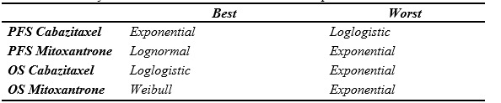
Table 1 presents the AIC values for all candidate parametric distributions fitted to the four survival datasets. For PFS, the exponential distribution provided the best statistical fit for Cabazitaxel, while the log-logistic distribution performed worst. For Mitoxantrone PFS, the log-normal distribution yielded the lowest AIC, with the exponential distribution ranking last. Regarding OS, the log-logistic distribution achieved the best fit for Cabazitaxel, whereas the Weibull distribution performed best for Mitoxantrone OS; in both cases, the exponential distribution produced the highest AIC values, indicating the weakest statistical fit. Notably, the exponential distribution performed poorly across three of the four datasets, suggesting it may not adequately capture the underlying hazard patterns in this population.

It is important to note that deciding solely based on the AIC-data may results in clinically implausible extrapolations. Therefore, the visual fit of the parametric curves to the observed KM data was also assessed. The fitted curves for all four datasets are presented in Appendix A (Figures A1-A4).

Assessment of parametric curves for OS
First, the parametric curves for OS were analysed. For Cabazitaxel, the AIC-data showed that the loglogistic (AIC: 1938.93) and Weibull (AIC: 1939.54) distribution both fitted the observed KM curves the best. However, the fitted survival curve (see Appendix A, Figure A1) shows that the Weibull distribution overestimates survival from t=15 and underestimates it from t=25. The loglogistic distribution follows the KM curve more closely.

For Mitoxantrone, the AIC-data showed that the Weibull-distribution had a slightly better fit. However, the fitted survival curve (see Appendix A, Figure A2) shows that the Weibull OS curve decreases very rapidly from t=20, approaching zero. At cycle 48, OS was only 4.3% for the Weibull distribution, compared to 10% for the lognormal and 9.7% for the loglogistic. This rapid decline was considered clinically implausible, as a small proportion of mCRPC patients were expected to survive beyond this point.

Based on both statistical fit and clinical plausibility, the loglogistic distribution was selected to model OS for both treatment arms.

Assessment of parametric curves for progression-free survival
For Cabazitaxel, the AIC-data showed the best fit for the exponential distribution. However, the fitted survival curve (see Appendix A, Figure A3) shows that both the Weibull and exponential distribution closely follow each other. The lognormal and loglogistic distribution overestimate the KM data from t=10, so they were not considered.
For Mitoxantrone, the AIC data showed that the lognormal distribution had the best fit with the KM data. Visually, as seen in Appendix A, Figure A4, almost no curve follows the extracted data perfectly.
Because the lognormal distribution showed an overestimation for Cabazitaxel, and for Mitoxantrone none of the distributions fit perfectly, the Weibull distribution was selected for PFS. The same distribution was applied to both treatment arms to ensure internal consistency of the model, as using different distributions for each arm could introduce structural bias into the comparison.
Calculating health states
The chosen parametric survival functions were implemented within the partitioned survival model. At each 3-week cycle in the model, the number of patients in SD was directly calculated by multiplying the cohort size (n = 1,000) by the PFS probability at that cycle. The number of patients in the dead state was calculated by multiplying the cohort size by 1 minus the OS probability of that cycle. The number of patients in progressed disease was calculated by multiplying the cohort size by the OS probability minus the PFS probability at that cycle, representing patients who are still alive, but whose disease has progressed. Half-cycle correction was applied to account for transitions occurring throughout the cycle rather than at a single time point.

In addition, the number of newly progressed patients at each cycle was calculated as the difference in the number of SD patients between consecutive cycles. This is based on the assumption that all patients leaving the SD state must go via progression, meaning no direct transition from SD to death is possible in the model (see Figure 1). This will give the upper bound of the number of patients that have newly progressed. Similarly, the number of ‘newly died’ patients at each cycle was calculated by the number of patients in the death health state cycle (t) minus the number of patients in the death health state in the previous cycle (t-1). These newly progressed and newly deceased counts were used to apply one-off costs at the point of progression and at the point of death, as described in the resource use and costs section.
The resulting patient counts and transition values formed the basis of the model trace.
HEALTH-RELATED QUALITY OF LIFE
The treatment effect section described how the chosen parametric survival functions were used to calculate the proportion of patients in each health state at every model cycle, with half-cycle correction applied. These proportions form the basis for calculating life years (LYs) and, subsequently QALYs.
LYs in SD were calculated by multiplying the half-cycle corrected proportion of patients in SD during a given cycle by the cycle length in years (3/52 of a year). Life years in the PD health state were calculated in the same way, using the half-cycle corrected proportion in PD. Half-cycle correction was applied because transitions between health states can occur at any point during a cycle rather than at a fixed time point. Furthermore, the corrected values provide a more accurate estimate of the average number of patients in each state during a cycle. Total LYs per patient were then obtained by summing across both health states and all model cycles and dividing this value by the cohort size.
To account for differences in health-related quality of life (HRQoL) between health states and across cycles, LYs were converted to QALYs by applying utility weights. A utility value represents a patient's quality of life on a scale from 0 (death) to 1 (perfect health). QALYs were calculated by multiplying the LYs accrued in each health state during a given cycle by the utility value assigned to that state and cycle. HRQoL data was not collected in the pivotal TROPIC trial (De Bono et al., 2010). Utility values were therefore obtained from the UK Early Access Programme (EAP) for Cabazitaxel. The EAP was a phase IIIB/IV open-label study (NCT01254279) conducted across 12 UK cancer centres, enrolling 112 patients with mCRPC who had progressed on or after docetaxel (Bahl et al., 2015). EQ-5D-3L data was collected at baseline and at alternate treatment cycles (before cycles 2, 4, 6, 8) as well as at the end of treatment. EQ-5D-3L responses were converted to a single utility index using the UK general population value set (Dolan et al., 1995).
These utility values were adopted in the NICE technology appraisal TA391 for Cabazitaxel (NICE, 2016a) and are used in our model. The specific values were taken from Table 10 of the NICE TA391 pre-meeting briefing document, which is part of the publicly available committee papers for TA391 (NICE, 2016b). This document summarises the evidence submitted by the manufacturer (Sanofi) and the assessment by the independent Evidence Review Group (ERG), providing the data inputs used in the economic model.
For SD, cycle-specific utility values were applied, reflecting an observed trend of improving HRQoL with successive treatment cycles (Table 2). These ranged from 0.704 in cycle 1 to 0.819 from cycle 10 onwards. For the PD health state, a constant utility of 0.627 was applied. This value was measured using the EQ-5D-3L questionnaire in patients whose cancer had progressed despite Cabazitaxel treatment, assessed 30 days after their final Cabazitaxel cycle (Bahl et al., 2015; NICE, 2016b). The dead state was assigned a utility of zero, meaning it does not contribute to the QALY calculation. It should be noted that in the NICE TA391 appraisal, the manufacturers assumed a utility of zero in the final three months of life, reflecting that patients nearing death are typically in very poor health (NICE, 2016b). This adjustment was not incorporated in our model.
The same utility values were used for both treatment arms, as there was no reason to expect HRQoL to differ between Cabazitaxel and Mitoxantrone for a given disease state. This approach is consistent with the NICE reference case, which recommends using health state-specific rather than treatment-specific utilities (NICE,2013).
Table 2. Utility values used in the economic model, by health state and treatment cycle.
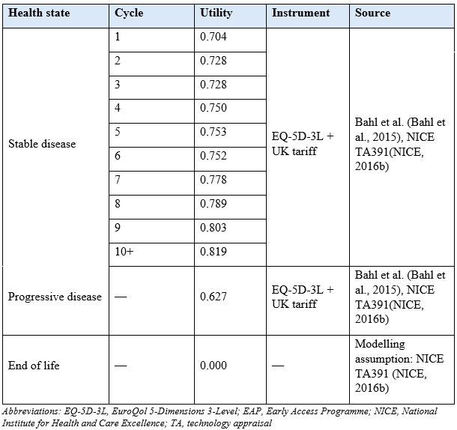
To illustrate how LYs and QALYs are derived in the model, consider cycle 4 of the Cabazitaxel arm. After half-cycle correction, 554.7 out of 1,000 patients are in the SD state. The LYs accrued in SD during this cycle are: 554.7 x (3/52) = 32.00 LYs. The corresponding QALYs are: 554.7 x (3/52) x 0.750 (the utility assigned to SD at cycle 4) = 24.00 QALYs. The same calculation was performed for the PD health state using the utility of 0.627. These calculations were repeated for each health state and each model cycle, excluding the dead state which has a utility of zero. Both LYs and QALYs were discounted at an annual rate of 3.5%, in accordance with NICE's methodological guidance (NICE, 2013). Total discounted LYs and QALYs were then obtained by summing across both health states and all cycles and dividing this value by the cohort size to obtain mean values per patient. The incremental LYs and QALYs were calculated as the difference between the Cabazitaxel and Mitoxantrone arm (i.e. Cabazitaxel minus Mitoxantrone). The increments were subsequently used to estimate the ICER.
In addition to health state utilities, the QALY loss attributable to AEs was incorporated. Disutility values were derived from a literature review conducted for the original NICE appraisal of Cabazitaxel (TA255), which identified disutility estimates from studies in breast and lung cancer, as no prostate cancer-specific values were available (NICE, 2016a; NICE, 2016b). These disutilities were applied to the incidence rates observed in the TROPIC trial for grade ≥3 AEs occurring in ≥5% of patients in either treatment arm (De Bono et al., 2010). The incidence, disutility weights, and durations for each AE are presented in Table 3.
Table 3. AEs incidence, disutility weights and durations used in the model.
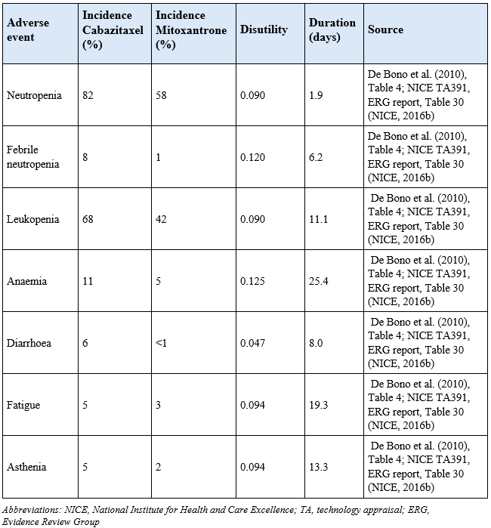
The total QALY loss per adverse event was calculated as the product of the incidence rate, the disutility weight, and the duration converted to years (i.e. days divided by 365). These were summed across all AEs to obtain the total QALY loss per treatment arm: 0.0038 for Cabazitaxel and 0.0021 for Mitoxantrone. These values were subtracted from the total QALYs per treatment arm as a lumpsum adjustment applied at the first model cycle to the whole cohort, since AEs can occur at any point during treatment and no cycle-specific timing data was available. No half-cycle correction was applied to the AE QALY loss, as this is a one-off adjustment.

Limitations
Several limitations of the utility data should be noted. First, the UK EAP was a single-arm study without a control group, meaning there is no comparison with untreated patients or those receiving Mitoxantrone. Because utilities were only measured in Cabazitaxel-treated patients, treatment-specific differences in HRQoL cannot be observed, and equal utilities had to be assumed across treatment arms, which may bias the incremental QALY estimates and therefore the ICER. Additionally, the number of patients with available EQ-5D data decreased at later treatment cycles: approximately 100 patients were assessed at baseline, but only 28 remained at cycle 10 (Bahl et al., 2015). This drop-off likely introduces selection bias, because patients who stayed on treatment longer were probably those doing better clinically, which may overestimate the utility values at later cycles.

A further limitation concerns the statistical uncertainty of the PD utility, specifically the value of 0.627 is based on measurements from only 25 patients, which makes this value uncertain (NICE, 2016b). The ERG (Evidence Review Group, the independent academic group that reviewed the manufacturer’s submission for NICE) tested how sensitive the model results are to this uncertainty by using the upper and lower bounds of the 95% confidence interval (CI = 0.510 - 0.743). When the lower bound was used, the ICER increased from approximately £49,300 to £55,200 per QALY gained; when the upper bound was used, it decreased to £44,600 per QALY gained (NICE, 2016b). This shows that the PD utility is an important driver of the model results.
Third, the patients in the UK EAP were less heavily pre-treated than those in TROPIC; only 11% had received two or more prior chemotherapy regimens, compared to 31% in TROPIC (Bahl et al., 2015; NICE, 2016b). Patients who have undergone fewer prior chemotherapy regimens have been exposed to less cumulative toxicity and are therefore likely to be in better overall physical condition at the start or treatment. This difference means the EAP patients may have been in somewhat better health, and utility values could have therefore slightly overestimate HRQoL for our modelled population.
Despite these limitations, the NICE appraisal committee accepted the UK EAP as the best available source of utility data for mCRPC patients after docetaxel failure, and no more recent disease-specific utility data have been identified for this population (NICE, 2016a). As described above, the same utility values were applied to both the Cabazitaxel and Mitoxantrone arms in our model.

RESOURCES USE AND COSTS

To calculate the ICER, all relevant cost inputs are incorporated into the model. For this, all necessary input parameters are identified from the perspective of the NHS and the personal social services (PSS), restricted to those applicable to the UK setting. All costs are adjusted to the 2023/2024 price index, and each type of cost is first calculated per person per cycle (except for the lumpsum, which already includes all cycles), which will be shown in more detail below.
Stable disease health state costs
Adverse events
Both treatment arms have adverse events (AEs), however with a different incidence. AEs that are of Grade 3, and higher and that have an incidence of at least 5% in either of the treatment arms are included in the calculation. The AEs that meet these requirements, together with their incidence per treatment arm, their treatment costs and the total cost of AEs per cycle, for Mitoxantrone and Cabazitaxel separately, are provided in Table 4 below. The cost of each AE is calculated by multiplying the incidence per treatment arm by the unit cost. After this, all costs for the AEs were added up to get the total costs of AEs per cycle, per treatment arm.
Even though fatigue and asthenia have the same unit costs, we chose to sample them differently, because fatigue is a temporary symptom while asthenia is chronic, which we also saw in the difference in average duration between the two.
Table 4. Incidence, treatment and total costs of adverse events
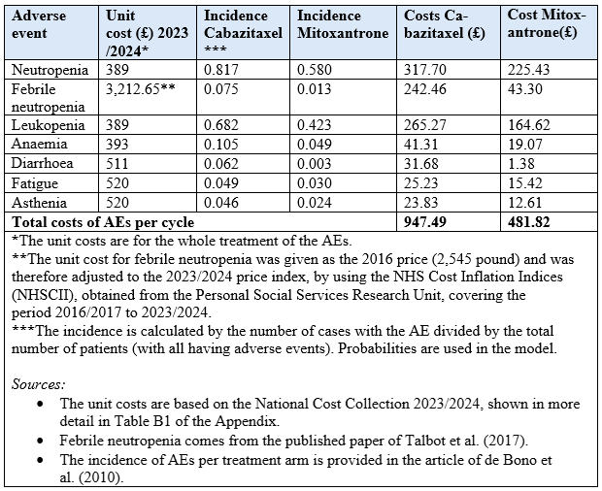

After calculating the total cost of AEs per cycle, these costs were used as a lumpsum in the 1st cycle of the model trace, applied to the whole cohort (n = 1000). This is done because it is uncertain when a patient will experience the AE. No half-cycle correction is applied here.

Drug acquisition costs
Cabazitaxel is administered intravenously in one dose of 25 mg/m² per cycle (Bono et al., 2010), where we used the cost price of a 60mg/1.5ml vial. Mitoxantrone is administered intravenously in one dose of 12 mg/ m² every cycle where a cost price of a 20mg/10ml vial is used. It is assumed that the vials are not shared between patients, resulting in wastage costs. Based on the paper of De Bono et al. (2010), it is assumed that patients have an average body surface of 2.01 m^{2.} The drug acquisition resource use and cost per cycle are presented in Table 5.
The dosage per cycle was calculated by the dose in mg/m² multiplied by the average body surface. After this, the number of vials needed per cycle was calculated by dividing the dosage per cycle by the dosage per vial. It is rounded up to take into account that vials cannot be shared between patients. The total cost per cycle was then calculated by multiplying the vials acquisition cost with the number of vials needed per cycle, resulting in the total drug acquisition cost per cycle, per treatment arm.
Table 5. Drug acquisition resource use and cost per cycle
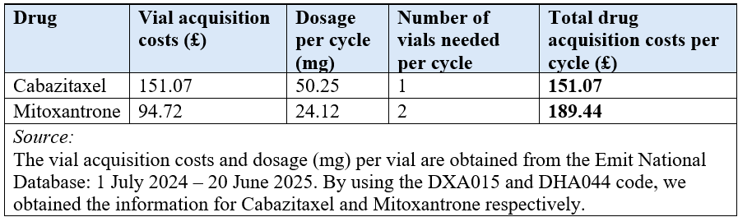
After calculating the total drug acquisition costs per cycle, these costs were used in the first 10 cycles of the model trace, applied to the people in SD. To minimize the risk of toxicity, the maximum number of cycles for both arms is 10. No half cycle correction was used here, since the drugs are administered at the beginning of the cycle.

Premedication costs
In both treatment arms, patients receive premedication once every cycle before the chemotherapy infusion to prevent some of the common adverse events. The percentage of patients in each arm that receive premedication is different, which is shown in Table 6. No wastage costs for premedication were assumed. The drug premedication resource use and cost per cycle are presented in Table 6.
The cost per tablet was calculated by dividing the cost per pack by the pack size. Since the dosage is given only once per cycle, it is also the cycle cost for each premedication, with not considering the percentage of patients receiving the premedication yet. To take this also into account, the cycle cost was multiplied by the prevalence in each arm.

Table 6. Premedication resource use and cost per cycle
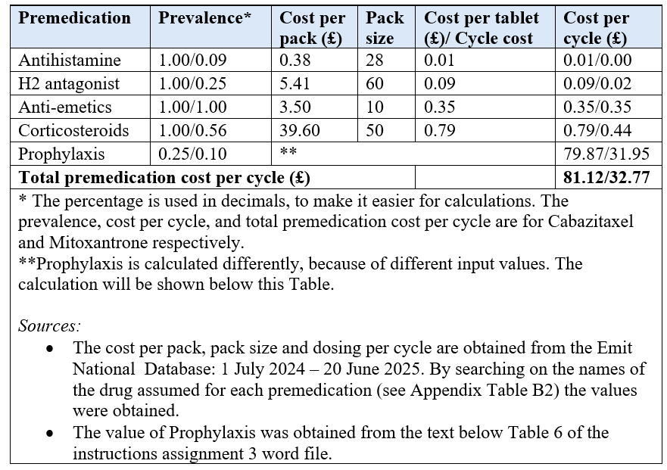
For prophylaxis, one dose of G-SCF is administered before the chemotherapy, and further doses are taken once a day after the chemotherapy, with an average duration of 4.1 days (including the pre-chemo dose). This makes the average dosing per cycle also 4.1. The dosage is 0.005mg/kg and an average body weight of 70 kg is assumed, based on the De Bono et al. paper (2010). Multiplying these two values gives a dosage of 0.35mg. The unit cost of 193.88/mg for year 2020/2021, is adjusted to the 2023/2024 price index, by using the inflation index rates of NHSCII of 2021/2022 until 2023/2024, resulting in a cost of 222.64/mg. The cycle cost, unadjusted for the prevalence, is then given by the multiplication of the cost/mg, the dosing per cycle and the dosage. Multiplying this with the prevalence of patients receiving the premedication results in a cost per cycle of 81.12 and 32.77 pounds for Cabazitaxel and Mitoxantrone respectively. The sum of all the premedication cost resulted in the total drug premedication cost per cycle, per treatment arm, as given in Table 6.
After calculating the total premedication cost per cycle, these costs were used in the first 10 cycle of the model trace, applied to the people in SD. No half cycle correction was used here, since most of the premedication is given at the beginning of the cycle.

Concomitant medication costs
The concomitant medication costs consist of a 5 mg Prednisolone tablet twice per day, and an LHRH agonist (50% Leuroprorelin and 50% Goserelin). All patients receive this medication for the remainder of their lifetime. The concomitant medication resource use and cost per cycle are presented in Table 7.
The cost per tablet for Prednisolone was calculated by dividing the cost per pack by the pack size. Since the drug was taken twice per day, the dosage per cycle is 42 tablets. The cycle cost for Prednisolone was then obtained by multiplying the dosage per cycle by the cost per tablet. For the LHRH agonist, a recent NICE submission (NICE TA995) already contained a weighted cost per cycle of 77.31 pounds. The total concomitant medication cost per cycle is obtained by the sum of the cycle cost of each medication.
Table 7. Concomitant medication resource use and cost per cycle
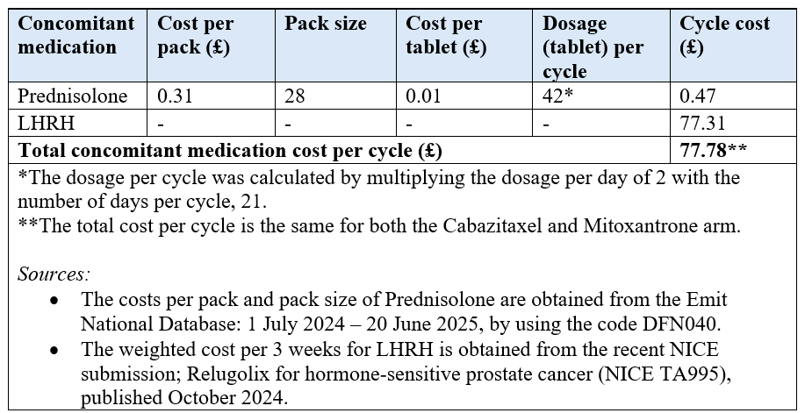
After calculating the total concomitant medication cost per cycle, these costs were used in each cycle of the model trace, applied to the people in SD. Half cycle correction was used here, since Prednisolone was taken twice each day and for the LHRH medication the moment of taking the medicine was unknown.

Chemotherapy administration costs
Since chemotherapy is administered via intravenous infusion, a medical professional is needed. It is assumed that the cost for this will consist of the preparation time of a pharmacist prior to the administration of the chemotherapy and an outpatient visit for the delivery of the chemotherapy, which is in line with the company submission from NICE TA391, Table 64. We assume that patients have had chemotherapy before, meaning we use the cost of the delivery of a subsequent cycle of chemotherapy. Because of the absence of the specific setting for the delivery of chemotherapy, the total unit cost of 430 pounds that includes all costs related to treatment administration, independent of the duration of the administration, is used. The chemotherapy administration resource use and cost per cycle are presented in Table 8.
Per cycle Cabazitaxel or Mitoxantrone is only administered once. The cost of the pharmacist per cycle is then calculated by the hourly cost of the pharmacist multiplied by the preparation time in hours. The total administration cost per cycle is obtained by the sum of the pharmacist cost and the cost of outpatient visit per cycle.

Table 8. Chemotherapy administration resource use and cost per cycle
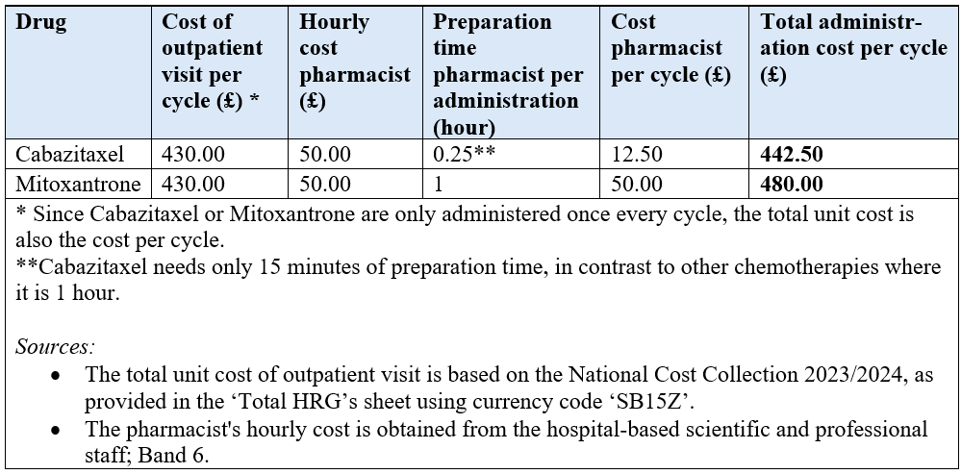
After calculating the total administration cost per cycle, these costs were used in the first 10 cycle of the model trace, applied to the people in the stable disease health state. No half cycle correction was used here, since chemotherapy is administered only once at the beginning of the cycle.

Health care resource use costs
There are a lot of different health care resources used, varying from inpatient to outpatient care. The average length of stay at the oncology and general ward is assumed to be 8.17 days. We chose to sample the average length of stay for the oncology and general ward differently, because these are two different departments specialized in different illnesses and symptoms. The fact that the average length of stay is the same in this case doesn't mean the wards are identical, and that's why we sample them differently. The same reasoning is used for the unit cost of the oncology, general and urology ward. The health care resource use and cost per cycle are presented in Table 9.
The resource use per cycle was calculated by multiplying the resource use for 3 months by 3/13. After this, the health care resource use cost per cycle was calculated by multiplying the health care resource unit cost with the health care resource use per cycle, for the outpatient care. For the inpatient care, this is calculated by multiplying the unit cost (here the cost per 24h) with the health care resource use per cycle and with the average length of stay (in days) per visit. The total health care resource cost per cycle is the sum of all the separate resource cost per cycle, and it is the same for both the Cabazitaxel and Mitoxantrone arm.

Table 9. Health care resource use and cost per cycle
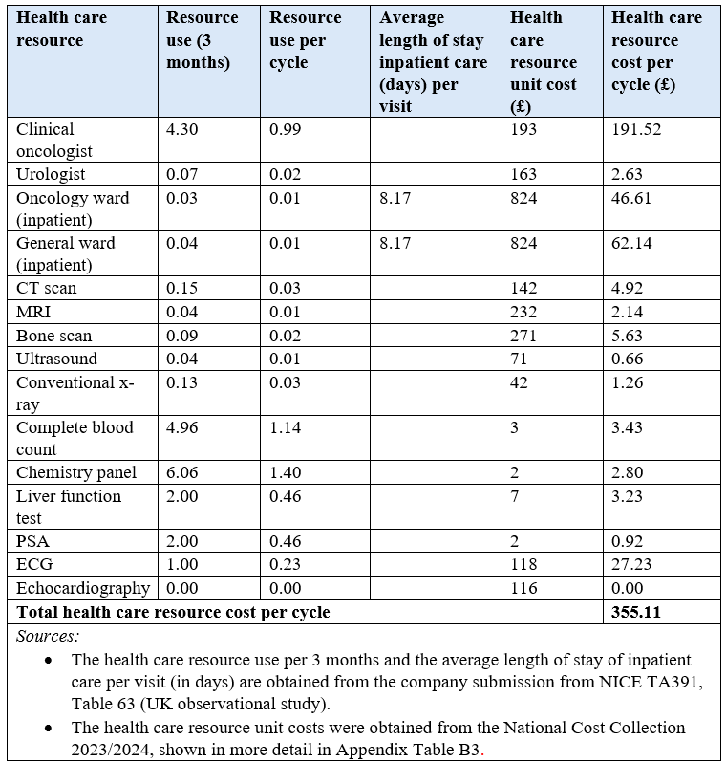
After calculating the total health care resource cost per cycle, these costs were used in each cycle of the model trace, applied to the people in SD. Half cycle correction was applied here, since it is unknown when patients use healthcare resources.

Progressed disease health state costs
Drug acquisition costs
In the TROPIC study (De Bono et al., 2010) 447 patients progressed, where 197 received only supportive care and the other 250 patients were in addition to this provided with further chemotherapy. According to observational data from the UK, three types of treatment are considered after patients with Cabazitaxel have progressed, namely Docetaxel, Mitoxantrone and Carboplatin-based regimens. For the Mitoxantrone arm, it is assumed that patients only receive Docetaxel or Carboplatin-based regimens when they progress. The proportions of the patients receiving each additional line of post-second line chemotherapy are provided in Table 10. They are calculated by dividing the number of patients per treatment by the total number of patients (6+3+2 for Cabazitaxel and 6+3 for Mitoxantrone).

Table 10. Number and proportions of patients receiving each additional line of chemotherapy
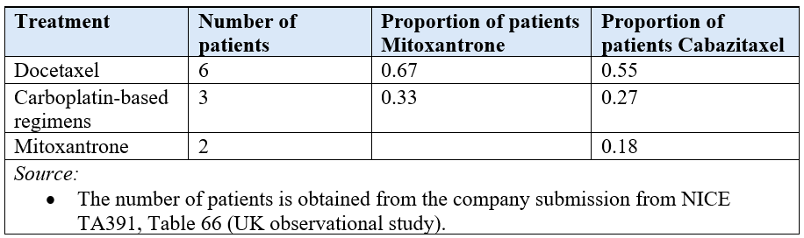
For the calculation of the post-second line chemotherapy, an average body surface area of 2.01 m² was assumed (De Bono et al., 2010). Another assumption made was that all drugs are only administered once per cycle. The post-second line chemotherapy use and cost are presented in Table 11.
The dosage per cycle was calculated by multiplying the dosage per m² by the body surface, and by the dosing per cycle (1 here). After this, the cost per cycle was calculated by multiplying the dosage per cycle with the cost per mg. Docetaxel and Mitoxantrone are only administered for a maximum of 10 cycles and Carboplatin-based regimens only for a maximum of 6 cycles. The post-progression treatment cost was calculated as a lumpsum cost, by multiplying the cost per cycle with the maximum number of cycles. This total cost needs to be adjusted for the proportion of patients that receive post-second-line chemotherapy (250/447) and for the proportion of patients receiving each specific additional line of chemotherapy, by multiplying the total cost with these proportions. The total drug acquisition cost as a lumpsum is the sum of the separate lumpsum cost of each drug.

Table 11. Post-second line chemotherapy use and cost as a lumpsum, Cabazitaxel
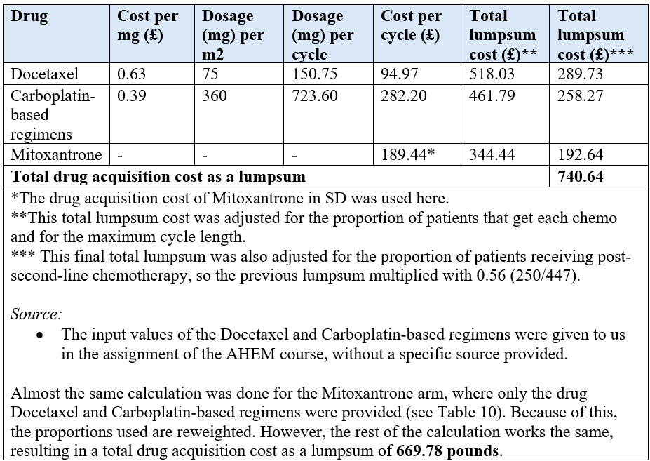
The adverse events associated with the post-second line chemotherapy were ignored for simplicity.
After the total drug acquisition costs were calculated as a lumpsum for each arm, these costs were used in each cycle of the model trace, applied as a one-off cost to newly progressed patients, at the moment they progress. No half-cycle correction was applied, since this is a transaction cost and not a health state cost.

Premedication and administration costs
The post-second line chemotherapy also has premedication and administration cost, that needs to be included. The total premedication and administration cost per cycle of Mitoxantrone in SD was used and adjusted for the proportion of patients that receive post-second-line chemotherapy (250/447) and for the proportion of patients receiving each specific additional line of chemotherapy, by multiplying the total cost with these proportions. The cost was also multiplied by the maximum number of cycles, to make it a lumpsum cost, shown below in Tables 12 and 13.

Table 12. Premedication use and cost as a lumpsum, Cabazitaxel
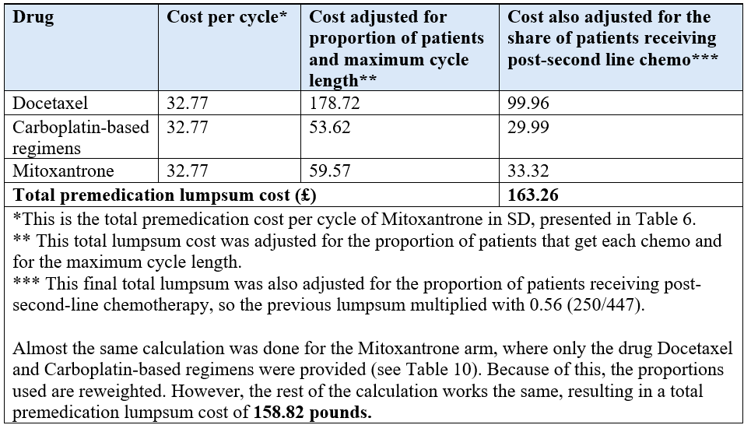
Table 13. Administration use and cost as a lumpsum, Cabazitaxel
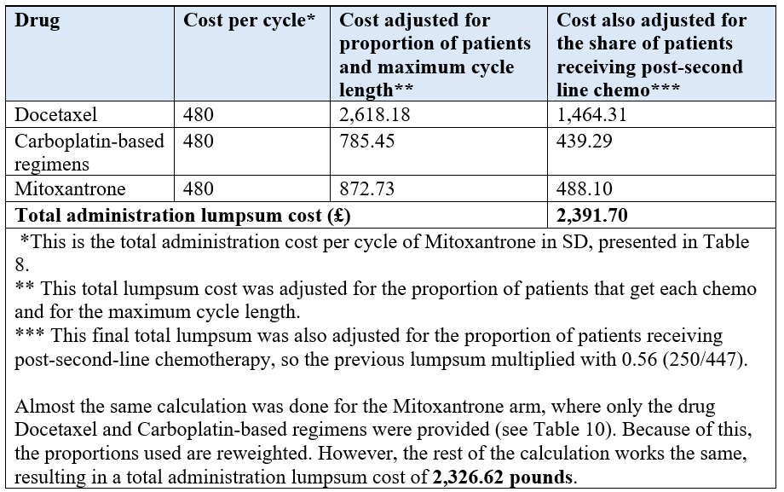
After calculating the total premedication and administration cost as a lumpsum for each arm, these costs were used in each cycle of the model trace, applied as a one-off cost to newly progressed patients at the moment they progress, like the drug acquisition costs. For the same reason, no half-cycle correction was applied here.

Concomitant medication costs
The same costs as in SD were used here, since it is assumed that patients continue receiving the same concomitant medication after progression, as they received in SD. So, the same total cost as in Table 7 was applied here without any adjustments.
This total concomitant medication cost per cycle was used in each cycle of the model trace, applied to the people in the PD state. Half cycle correction was applied, since Prednisolone was taken twice each day and for the LHRH medication the moment of taking the medicine was unknown.

Health care resource use costs
The frequency of health care resource use is different for patients who only have supportive care compared to patients that also receive an additional line of chemotherapy. It is assumed that the urology ward has the same unit cost of 824 pounds as the oncology and general ward, and that the average length of stay in the oncology, general or urology ward is 6.5 days. Again, we chose to sample the costs and average length of stay for the different wards differently, with the same reasoning as before in SD. The health care resource use and cost are presented in Table 14.
The same calculation steps are followed as for the health care resource use cost in SD. The only difference is that we did this calculation now two times, once for the best supportive care patients only and once for the patients that also receive additional chemotherapy. After obtaining these total health care resource use costs per cycle, the costs still need to be adjusted for the proportion of patients that receive either best supportive care only or also the additional chemotherapy. The sum of these two adjusted costs resulted in the total healthcare resource use cost per cycle that is used in each cycle of the model trace, applied to the people in the PD health state. Half-cycle correction was applied here, since it is unknown when patients use healthcare resources.

Table 14. Health care resource use and cost per cycle, PD
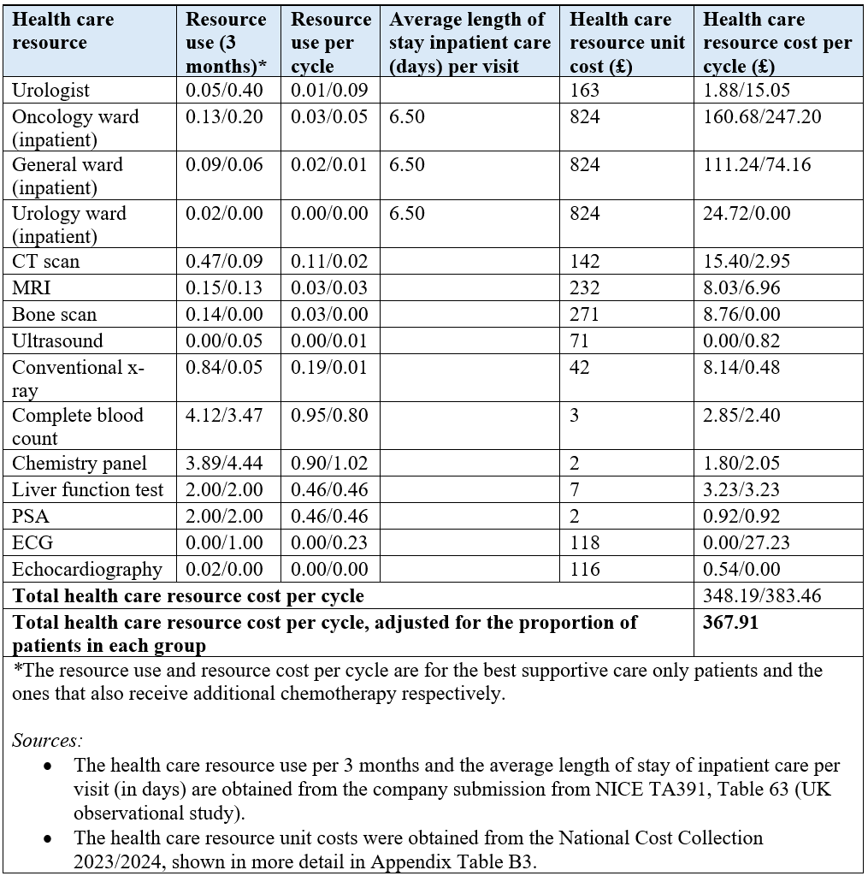

Best supportive care costs
Each patient gets best supportive care after they progress, which consists of steroids, analgesics, bisphosphonate and palliative radiotherapy. For this, an overall cost of 41.68 pounds per cycle was used, which comes from the ERG report of TA391, p115. The cost price applies to the year 2014/2015 (41.68 pounds) and was therefore adjusted to the 2023/2024 price index by using the NHS Cost Inflation Indices (NHSCII), obtained from the Personal Social Services Research Unit, covering the period 2015/2016 to 2023/2024. This resulted in a total cost of 52.82 pounds per cycle.
After calculating the total supportive care cost per cycle, these costs were used in each cycle of the model trace, applied to the people in the progression health state. Half cycle correction is used here, since it is unknown when best supportive care was given to the patients.

End of life costs
The end-of-life cost is assumed to be 6,202 pounds, assumed to consist of 30 days of palliative care, where the average value for those above an age of 19 is taken from the PSSRU 2023. The cost price applies to the year 2023 and was therefore adjusted to the 2023/2024 price index by using the NHS Cost Inflation Index 2023/2024 (NHSCII), obtained from the Personal Social Services Research Unit, resulting in a total cost of £6,469.31.
This cost was applied in each cycle of the model trace to all patients that enter the death health state during that cycle. These are the 'newly died' patients in the model trace. No half-cycle correction was applied here, since this is a transition cost and not a health state cost.

Application to model trace
After the application of each separate type of cost to the model trace, the costs were discounted at a rate of 3.5% per year to account for time preference, in accordance with NICE methodological guidance (NICE, 2013). Then all costs were summed up for each cycle across both health states. The total cost across all cycles was also summed up and divided by the cohort size to obtain the mean total cost for each treatment arm. The discounted mean costs were used to calculate the incremental cost, as the cost of Cabazitaxel minus the cost of Mitoxantrone, which was eventually used in the estimation of the ICER.
In addition to the ICER, the net monetary benefit (NMB) is reported as a supplementary measure of cost-effectiveness. The NMB converts costs and health benefits into a single monetary value at a given willingness-to-pay (WTP) threshold, using the formula: NMB = (WTP × ΔQALYs) − ΔCosts. A positive incremental NMB indicates that the intervention is cost-effective at the specified threshold. Results are presented at a WTP of £70,000 per QALY, in line with NICE's end-of-life criteria applicable to this patient population (NICE, 2013).

SENSITIVITY ANALYSIS
As noted above, the input parameters of the model were extracted from various sources and databases. These parameters are estimates and are therefore sensitive to uncertainty (Drummond et al., 2005). To account for this parameter uncertainty, sensitivity analyses were conducted. A sensitivity analysis consists of varying uncertain model parameters within defined plausible ranges to evaluate the impact of this uncertainty on the model outcomes (Drummond et al., 2005). The standard errors, standard deviation and quantity input values we got for the PSA are given in Appendix C, Table C1- C3.
Probabilistic sensitivity analysis
A probabilistic sensitivity analysis (PSA) was conducted to assess the joint uncertainty across all input parameters simultaneously. Unlike a deterministic sensitivity analysis, in which individual parameters are varied one at a time, a PSA assigns probability distributions to all uncertain parameters and varies them simultaneously across multiple simulations (Drummond et al., 2005). This approach was chosen because it captures the combined effect of parameter uncertainty on the ICER and allows the probability of cost-effectiveness to be estimated at different WTP thresholds.

The PSA conducted for our model consisted of three steps. First, the probability distribution for each uncertain parameter was defined. Then, a random value was drawn for each distribution, after which the ICER was calculated. This process was repeated 1000 times.

Parameter distributions
It is important to note that not all parameters in our study were subject to uncertainty; some were considered fixed and therefore no probability distribution was assigned. This included input parameters where the estimations were definite, such as the dosage of a drug and scenarios where all patients receive a drug, or where the estimations were derived from policy choices, such as the annual inflation rates and discount rates (Drummond et al., 2005).

For the remainder of the parameters, probability distributions were defined. Parameters that are constrained between 0 and 1, such as the (health state) (dis)utility values and AE incidence rates, were defined under a beta distribution. Parameters that can only be positive, such as costs or number of days, were defined under a gamma distribution. For parameters where multiple mutually exclusive categories must sum to 1, such as the treatment proportions for each post-second-line chemotherapy, a Dirichlet distribution was used. An overview of the probability distributions has been provided in Appendix C, Table C4.
For the survival curve parameters (intercept and scale), correlated random draws were generated using the Cholesky decomposition matrix, which was obtained from the R output of the parametric survival models. This approach preserves the correlation structure between the parameters of each survival distribution, ensuring that the extrapolated survival curves in the PSA remain internally consistent.

Parameter uncertainty
To estimate the parameters of the distributions, the alpha, beta and standard errors (SE), if available, were used. If only the standard deviation (SD) was available, the SE was derived by dividing the SD by the square root of the sample size. If the SE for a parameter was not provided, we assumed the size of the SE as a percentage of the mean.

For clinical and utility parameters, a SE equal to 5% or 10% of the mean was assumed, depending on the expected level of uncertainty. For the parameter “average body surface”, a SE of 5% of the mean was chosen, because the estimation is based on the TROPIC trial where the population consisted of men who were mostly above the age of 65. We assumed that there is limited variation in the characteristics of the patient group and therefore less uncertainty. For the parameter "average duration of adverse events" however, we used a SE of 10% of the mean, as the duration of adverse events is dependent on the individual and therefore more uncertain.
For cost inputs, the SE assumption depends on the complexity of the cost, where we used a SE with a range from 10%-20% of the mean. For example, a SE of 10% of the mean for simple unit costs, such as the unit costs of Docetaxel and Carboplatin-based regimens, was considered sufficient because these are not aggregated costs and therefore carry less uncertainty. However, for most of the other cost parameters, which were extracted from databases that use aggregated values, e.g. National Cost Collection, we applied a SE of 20% of the mean, as these parameters are more uncertain. An overview of the assumed SEs is provided in Appendix C, Table C5.
Furthermore, where possible, the alpha and beta were calculated using the TROPIC trial data or method of moments formulae. The latter have been provided in Appendix C, Table C6.
If the alpha and beta of a parameter were available from the source data or successfully calculated, there was no need to assume a SE for said parameter.
After all the probability distributions were defined for the uncertain parameters, the PSA values were drawn in Excel, using the formulae provided in Appendix C, Table C6. A macro in Visual Basic for Applications (VBA) was used to perform the 1,000 simulations, generating the probabilistic ICER, a cost-effectiveness plane (CE-plane) and a cost-effectiveness acceptability curve (CEAC).

Scenario analyses
In addition to the PSA, several scenario analyses were performed to assess the sensitivity of the model results to key structural and parameter assumptions.
Survival distribution scenarios
The choice of parametric distribution for the survival curves is one of the most influential assumptions in the model, as it directly affects the extrapolated OS and PFS, and therefore the time spent in each health state. To test the impact of this choice, we repeated the analysis using an exponential distribution for both OS and PFS. The exponential distribution was selected for this scenario because it had the highest AIC score (i.e. the worst statistical fit) for both treatment arms in OS and for Mitoxantrone in PFS (see Table 1), and it also showed the poorest visual fit to the KM data (see Appendix A). Using the worst-fitting distribution provides a stress test of the base-case results, as it represents the most extreme alternative extrapolation.

Vial sharing scenario
In the base case, it was assumed that vials are not shared between patients, meaning that any unused portion of a vial is wasted. To test the impact of this assumption, a scenario was run in which vial sharing was allowed, removing the wastage costs for drug acquisition in both SD and PD.

Standard error assumption scenarios
The SE for several parameters was assumed as a percentage of the mean (ranging from 5% to 20%), as described in the PSA section. To assess how these assumptions affect the uncertainty around the ICER, two additional scenarios were run. In the first scenario, the maximum SE percentages were applied to all parameters (i.e. 20% for all cost parameters and 10% for all others). In the second scenario, the minimum SE percentages were applied (i.e. 10% for all cost parameters and 5% for all others). For each scenario, the PSA was re-run with 1,000 simulations.

RESULTS

BASE-CASE DETERMINISTIC RESULTS
The base-case deterministic results, discounted at 3.5% per year and with half-cycle correction applied, are presented in Table 15. Treatment with Cabazitaxel plus Prednisone resulted in higher total costs (£28,687) compared to Mitoxantrone plus Prednisone (£24,125), yielding an incremental cost of £4,563 per patient. Cabazitaxel also produced greater health benefits, with 1.155 QALYs and 1.772 LYs compared to 0.874 QALYs and 1.346 LYs for Mitoxantrone. The incremental gain was 0.281 QALYs and 0.426 LYs, resulting in an ICER of £16,253 per QALY gained and £10,716 per LY gained. The net monetary benefit (NMB), calculated at a WTP threshold of £70,000 per QALY, was £52,320 for Cabazitaxel plus Prednisone and £37,163 for Mitoxantrone plus Prednisone, yielding an incremental NMB of £15,157 in favour of Cabazitaxel plus Prednisone.
Table 15. Base-case deterministic results: mean discounted costs and effects per patient, by treatment arm.
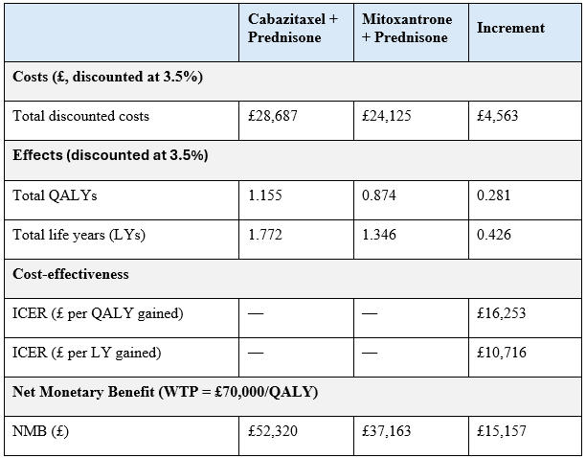Abbreviations: QALY = quality-adjusted life year; LY = life year; ICER = incremental cost-effectiveness ratio; NMB = net monetary benefit; WTP = willingness-to-pay threshold.
The disaggregated costs and effects per treatment arm are presented in Table 16. Total SD costs were £7,164 for Cabazitaxel and £5,457 for Mitoxantrone, with an incremental difference of £1,706. The largest cost components in SD were chemotherapy administration costs (£2,324 for Cabazitaxel, £2,071 for Mitoxantrone) and healthcare resource use costs (£2,192 for Cabazitaxel, £1,596 for Mitoxantrone). AE costs differed by £466 between the two arms (£947 for Cabazitaxel, £482 for Mitoxantrone). Drug acquisition costs in SD were slightly lower for Cabazitaxel (£793) than for Mitoxantrone (£817).
Total PD costs were £15,484 for Cabazitaxel and £12,514 for Mitoxantrone, with an incremental difference of £2,970. Healthcare resource use was the largest cost component in PD (£9,028 for Cabazitaxel, £6,930 for Mitoxantrone), followed by chemotherapy administration costs (£2,360 for Cabazitaxel, £2,304 for Mitoxantrone) and concomitant medication costs (£1,908 for Cabazitaxel, £1,465 for Mitoxantrone). End-of-life costs were £6,039 for Cabazitaxel and £6,153 for Mitoxantrone, with Cabazitaxel being £114 lower.
On the effects side, Cabazitaxel patients accrued 0.356 LYs in SD and 1.416 LYs in PD, compared to 0.259 and 1.087 LYs for Mitoxantrone respectively. QALYs accrued in SD were 0.271 for Cabazitaxel and 0.195 for Mitoxantrone. QALYs accrued in PD were 0.888 for Cabazitaxel and 0.681 for Mitoxantrone. QALYs lost due to AEs were 0.004 for Cabazitaxel and 0.002 for Mitoxantrone.
Table 16. Disaggregated costs and effects per patient, by treatment arm and health state (discounted at 3.5% per year).
 | Cabazitaxel + Prednisone | Mitoxantrone + Prednisone | Increment
Stable Disease (SD) costs
Chemotherapy administration | £2,324 | £2,071 | £253
Healthcare resource use | £2,192 | £1,596 | £596
Drug acquisition costs | £793 | £817 | -£24
Adverse event costs | £947 | £482 | £466
Concomitant medication costs | £908 | £491 | £417
Total SD costs | £7,164 | £5,457 | £1,706
Progressive Disease (PD) costs
Drug acquisition costs post- progression chemo | £731 | £663 | £68
Chemotherapy administration costs | £2,360 | £2,304 | £56
Premedication costs | £161 | £157 | £4
Healthcare resource use costs | £9,028 | £6,930 | £2,098
Concomitant medication costs | £1,908 | £1,465 | £443
Best supportive care costs | £1,296 | £995 | £301
Total PD costs | £15,484 | £12,514 | £2,970
End-of-life costs
End-of-life costs | £6,039 | £6,153 | -£114
Effects (discounted at 3.5%)
LYs in SD | 0.356 | 0.259 | 0.097
LYs in PD | 1.416 | 1.087 | 0.329
Total LYs | 1.772 | 1.346 | 0.426
QALYs in SD | 0.271 | 0.195 | 0.076
QALYs in PD | 0.888 | 0.681 | 0.207
QALYs lost due to AEs | -0.004 | -0.002 | -0.002
Total QALYs | 1.155 | 0.874 | 0.281
Abbreviations: SD = stable disease; PD = progressive disease; AE = adverse event; LY = life year; QALY = quality-adjusted life year.

PROBABILISTIC SENSITIVITY ANALYSIS RESULTS
The results of the PSA, based on 1,000 simulations, are presented in Table 17. Mean total discounted costs were £28,778 for Cabazitaxel and £24,190 for Mitoxantrone, resulting in mean incremental costs of £4,588. Mean total discounted QALYs were 1.157 for Cabazitaxel and 0.876 for Mitoxantrone, resulting in an incremental gain of 0.28 QALYs. The probabilistic ICER was £16,308 per QALY gained and £10,743 per LY gained. These values are consistent with the deterministic base-case results (ICER: £16,253 per QALY gained).
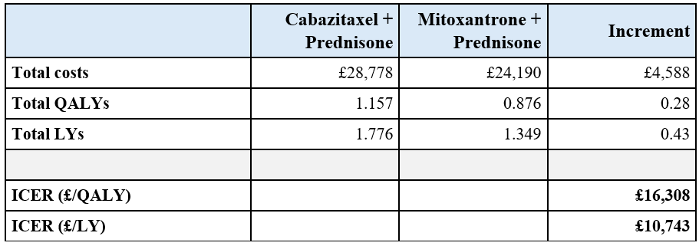
Table 17. Probabilistic sensitivity analysis results: mean discounted costs and effects per patient (1,000 simulations).

Abbreviations: LY, life year; QALY, quality-adjusted life year; ICER, incremental cost-effectiveness ratio. All costs in 2023/2024 GBP, discounted at 3.5% per year.
Figure 2 presents the cost-effectiveness plane from the PSA. All 1,000 simulations are located in the north-east quadrant, indicating that Cabazitaxel plus Prednisone is associated with higher costs and greater health benefits compared to Mitoxantrone plus Prednisone across all iterations. The simulation points form a narrow, linear cluster, suggesting limited variability in the direction of the incremental costs and effects.

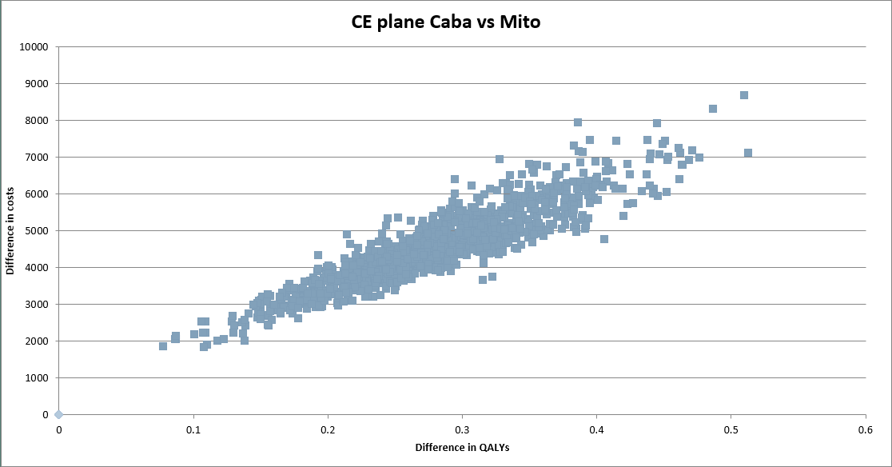
Figure 2. Cost-effectiveness plane from the probabilistic sensitivity analysis (1,000 simulations): Cabazitaxel plus Prednisone versus Mitoxantrone plus Prednisone.
Figure 3 presents a Cost-effectiveness Acceptability Curve (CEAC) for Cabazitaxel plus Prednisone compared to Mitoxantrone plus Prednisone. The x-axis displays the threshold Incremental Cost-effectiveness Ratio (ICER), ranging from 0 to 80,000. The y-axis shows the probability that Cabazitaxel plus Prednisone is cost-effective compared to the comparator, on a scale from 0.00 to 1.00. The curve rises steeply between a threshold of approximately £15,000 and £20,000, after which it levels off at a value close to 1.00.
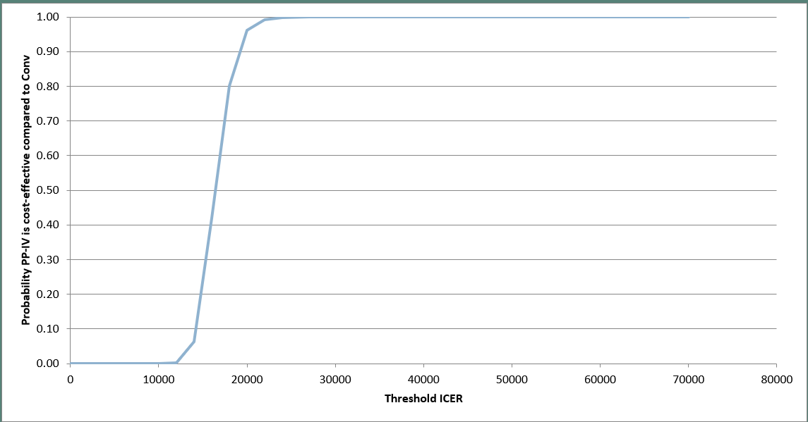

Figure 3. Cost-effectiveness acceptability curve (CEAC): probability of Cabazitaxel plus Prednisone being cost-effective compared to Mitoxantrone plus Prednisone across WTP thresholds

SCENARIO ANALYSES RESULTS
The results of the scenario analyses are presented in Table 18. In Scenario 1, using the exponential distribution for both OS and PFS resulted in an incremental cost of £4,302, incremental QALYs of 0.263, and an ICER of £16,383. In Scenario 2, removing the vial wastage assumption resulted in an incremental cost of £4,683, incremental QALYs of 0.281, and an ICER of £16,681. Scenarios 3 and 4, which applied the minimum and maximum standard error percentages respectively, both produced incremental costs of £4,546 and incremental QALYs of 0.28, yielding ICERs of £16,214 and £16,332.
Table 18. Results of scenario analyses showing the differences in delta costs, delta QALYs and the ICERs for Cabazitaxel plus Prednisone compared to Mitoxantrone plus Prednisone compared to the base case.
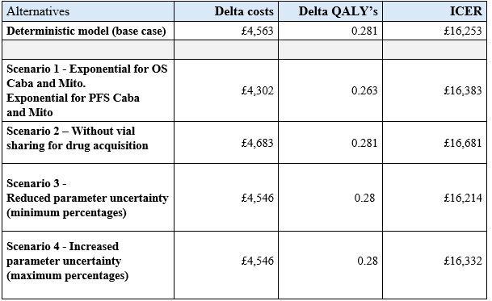

KEY MODELLING CHOICES AND ASSUMPTIONS
Table 19. Expected consequences of modelling choices and assumptions on cost-effectiveness
Underestimation of cost-effectiveness (ICER too high) | Overestimation of cost-effectiveness (ICER too low) | Unknown direction
• A discount rate of 3.5% was applied to both costs and effects. Since Cabazitaxel generates health benefits over a longer period than Mitoxantrone, a lower discount rate for effects would increase incremental QALYs and lower the ICER.  • Drug acquisition costs are based on eMIT procurement prices. If actual prices paid by NHS hospitals are lower due to confidential discounts or patient access schemes, total Cabazitaxel costs may be lower than modelled.  • AEs associated with post-progression chemotherapy were not included in the model. Including these would increase PD costs for both arms, but since more Cabazitaxel patients survive to receive post-progression treatment, the incremental costs may be underestimated. | • Utility values from the UK EAP may overestimate HRQoL due to selection bias: patients assessed at later treatment cycles were likely those responding well to treatment. Since Cabazitaxel patients spend more time in stable disease, this disproportionately increases the QALYs in the Cabazitaxel arm.  • EAP patients were less heavily pre-treated than TROPIC patients (11% vs 31% had received two or more prior chemotherapy regimens), and are therefore likely to have been in better physical condition, meaning utility values may overestimate HRQoL for the modelled population (Bahl et al., 2015, NICE, 2016b).  • The model does not allow direct transitions from SD to death. All patients must pass through PD before dying, which may overestimate the time spent in PD and therefore the incremental QALYs.  • Cycle-specific utilities for SD increase from 0.704 to 0.819. Cabazitaxel patients who remain in SD longer benefit disproportionately from higher utilities at later cycles.  • The number of newly progressed patients was approximated as PFS (t-1 minus) PFS (t). This represents an upper bound, as some patients may die while in SD rather than progressing, meaning the post-progression costs applied to these patients may be overestimated.  • HC resource use frequencies in SD are the same for both treatment arms. If Cabazitaxel patients require fewer healthcare contacts due to better disease control, the model overestimates Cabazitaxel costs in SD. | • The loglogistic distribution was selected for OS based on AIC and visual fit. Alternative distributions would produce different survival extrapolations, and the impact on the ICER depends on the relative change for each treatment arm.  • The Weibull distribution was selected for PFS for both arms to ensure internal consistency, even though different distributions provided the best fit for each arm individually.  • The same utility values were applied to both treatment arms, as no Mitoxantrone-specific utility data was available. If HRQoL differs between treatments for a given health state, the incremental QALY estimate could change in either direction.  • AE disutilities were derived from studies in breast and lung cancer as a proxy, since no mCRPC-specific values were available (NICE, 2016a; NICE 2016b). These may over- or underestimate the true QALY impact.  • The PD utility of 0.627 is based on only 25 patients, making it statistically uncertain. The ERG showed the ICER is sensitive to this parameter (range: £44,600–£55,200 per QALY).  • No vial sharing was assumed. Allowing vial sharing would reduce drug costs for both arms, but the effect on the incremental cost difference is uncertain.  • Post-progression chemotherapy proportions are based on a very small sample from a UK observational study (6 Docetaxel, 3 Carboplatin-based, 2 Mitoxantrone out of 11 patients). Different proportions could change PD costs in either direction.  • End-of-life costs are based on an assumed 30 days of palliative care (average for patients aged 19 and over). Actual end-of-life care duration and costs may differ for mCRPC patients specifically.  • BSC costs were derived from the ERG report of TA391 (2014/2015 prices) and indexed to 2023/2024. Treatment patterns and costs in PD may have changed since then.  • A lifetime horizon of 15 years was used, which is considered sufficient given the median OS of approximately 15 months. If a small proportion of patients survive beyond this period, some costs and QALYs may not be captured.
Abbreviations: OS, overall survival; PFS, progression-free survival; SD, stable disease; PD, progressive disease; AE, adverse event; ICER, incremental cost-effectiveness ratio; QALY, quality-adjusted life year; LY, life year; EAP, Early Access Programme; HRQoL, health-related quality of life; ERG, Evidence Review Group; eMIT, electronic market information tool; HC, healthcare; BSC, best supportive care.

APPENDIX

APPENDIX A – Survival curve fitting

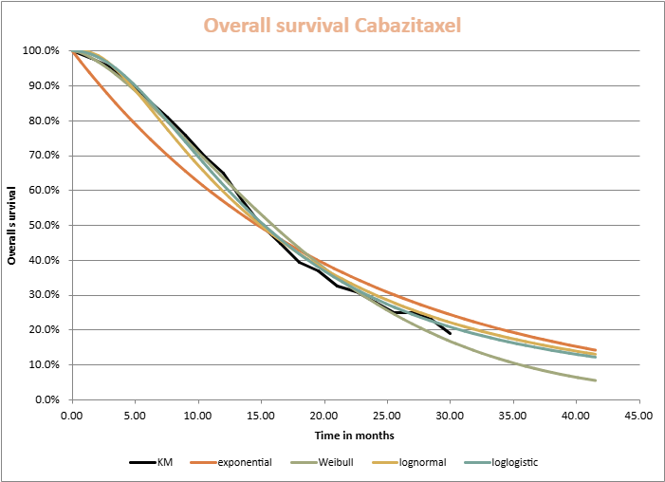

Figure A1. Observed Kaplan-Meier curve for overall survival with fitted parametric distributions for Cabazitaxel.

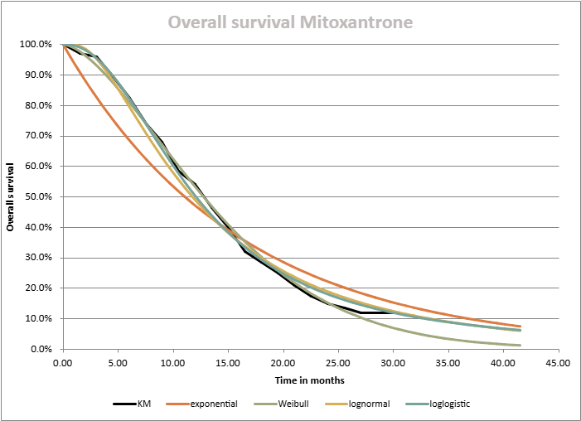

Figure A2. Observed Kaplan-Meier curve for overall survival with fitted parametric distributions for Mitoxantrone.

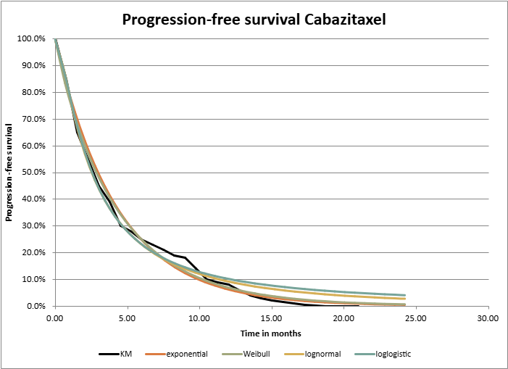
Figure A3. Observed Kaplan-Meier curve for progression-free with fitted parametric distributions for Cabazitaxel.

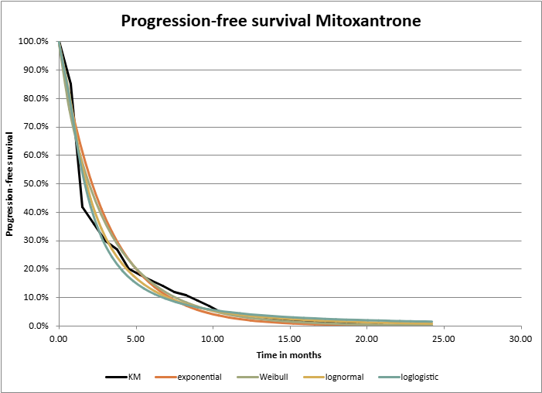
Figure A4. Observed Kaplan-Meier curve for progression-free with fitted parametric distributions for Mitoxantrone.

APPENDIX B – Sources of resources use and costs
Table B1. Sources unit cost of adverse events
Adverse event | Source
Neutropenia | National Cost Collection 2023/2024: sheet Admitted Patient Care (APC); weighted average of SA35A-E; Day Case; round value
Febrile neutropenia | Talbot at al. 2017 (2016 price); (SD: £2458); source is for costs of neutropenic sepsis, assumed to be the same as febrile neutropenia
Leukopenia | National Cost Collection 2023/2024: weighted average of SA35A-E; Day Case
Anaemia | National Cost Collection 2023/2024: weighted average of: SA01G-K, SA03G-H, SA04G-L, SA05G-J; Day Case
Diarrhoea | National Cost Collection 2023/2024: weighted average of: FD10J-M; Day Case
Fatigue | National Cost Collection 2023/2024: sheet Admitted Patient Care (APC); weighted average calculated from: SA01G-K; Day Case, round value
Asthenia | Assumed same as fatigue
Note: Detailed information is given about how the unit cost of each adverse event is derived from the National Cost Collection 2023/2024.

Table B2. Sources input values of premedication
Premedication | Drug assumed | Source
Antihistamine | Chlorphenamine | Emit National Database: 1 july 2024- 30 june 2025: Name & Pack Size = Chlorphenime
H2 antagonist | Cimetidine | Emit National Database: 1 july 2024- 30 june 2025: Name & Pack Size = Cimetidine
Anti-emetics | Ondansetron | Emit National Database: 1 july 2024- 30 june 2025: NPC code = DDF029
Corticosteroids | Dexamethasone | Emit National Database: 1 july 2024- 30 june 2025: Name & Pack Size = Dexamethasone
Prophylaxis | G-SCF | Given in the AHEM assignment
Note: Detailed information is given about how the input values of each premedication is derived from the eMIT (except from Prophylaxis).

Table B3. Sources health care resource use unit costs
Resource item | Source
Clinical oncologist | Summary: Outpatient Attendance: Currency: WF01A: Non-Admitted Face-to-Face Attendance, Follow-up; Service code 370: Medical Oncology Service – Consultant led
Urologist | Summary: Outpatient Attendance: Consultant-led; WF01A: Non-Admitted Face-to-Face Attendance, Follow-up; Service code 101: Urology
Oncology/ General / Urology ward | Summary: HRG Costs: Non-elective Inpatient Short Stay; Weighted average of currency codes LB06H, LB06J, LB06K, LB06L, LB06M, LB06N, LB06P, LB06Q, LB06R, LB06S
CT Scan | Total HRGs; RD22Z: Computerised Tomography Scan, one area, pre and post contrast, Total
MRI | Total HRGs; RD03Z: Magnetic Resonance Imaging Scan of one area, with pre and post contrast, directly accessed
bone scan | Total HRGs; RN15A: Nuclear Bone Scan of Two or Three Phases, 19 years and over, directly accessed
Ultrasound | Total HRGs; Weighted average of RD40Z, RD41Z, RD42Z, RD43Z, directly accessed
X-ray | Other Currencies; PF: Plain Film, directly accessed
Complete blood count | Directly Accessed Pathology Services; PATH05 - Haematology
Chemistry panel | Directly Accessed Pathology Services; PATH02 – Clinical Chemistry
Liver function test | Directly Accessed Pathology Services; PATH08 - Phlebotomy
PSA | Directly Accessed Pathology Services; PATH02 – Clinical Chemistry
ECG | Total HRGs tab; EY51Z: Electrocardiogram Monitoring or Stress Testing, total
Echocardiogram | Total HRGs; RD51A: Simple Echocardiogram, 19 years and over
Note: Detailed information is given about how the unit cost of each health care resource use is derived from the National Cost Collection 2023/2024.

APPENDIX C – Sensitivity analysis
Table C1. Disutility, standard error
Adverse event | Standard Error
Neutropenia | 0.0157
Febrile neutropenia | 0.0209
Leukopenia | 0.0157
Anaemia | 0.0217
Diarrhoea | 0.0082
Fatigue | 0.0163
Asthenia | 0.0163
Source: NICE TA391, ERG report, Table 30

Table C2. Emit inputs, quantity and standard deviation
Drug | Quantity | Standard deviation
Cabazitaxel | 1621 | 43.75
Mitoxantrone | 797 | 22.78
Antihistamine (Chlorphenamine) | 171,172 | 0.21
H2 antagonist (Cimetidine) | 1718 | 1.71
Anti-emetics (Ondansetron) | 225,101 | 1.11
Corticosteroids (Dexamethasone) | 4435 | 3.60
Prednisolone | 2,320,376 | 0.06
Source: Emit National Database: 1 July 2024- 30 June 2025

Table C3. Health care resource use, standard error
Resource | Standard error SD | Standard error PD  Best supportive care | Standard error PD  Additional chemo
Clinical oncologist | 0.358 | - | -
Urologist | 0.006 | 0.004 | 0.033
Oncology ward (inpatient care) | 0.003 | 0.011 | 0.017
General ward (inpatient care) | 0.003 | 0.008 | 0.005
Urology ward (inpatient care) | - | 0.002 | 0.000
CT scan | 0.013 | 0.039 | 0.008
MRI | 0.003 | 0.013 | 0.011
Bone scan | 0.008 | 0.012 | 0.000
Ultrasound | 0.003 | 0.000 | 0.004
Conventional x-ray | 0.011 | 0.070 | 0.004
Complete blood count | 0.413 | 0.343 | 0.289
Chemistry panel | 0.505 | 0.324 | 0.370
Liver function test | 0.167 | 0.167 | 0.167
PSA | 0.167 | 0.167 | 0.167
ECG | 0.083 | 0.000 | 0.083
Echocardiography | 0.000 | 0.002 | 0.000
Source: Company submission from NICE TA391, Table 63 (UK observational study), SD = Stable Disease, PD = Progressive Disease

Table C4. Probability distributions and their assigned modelled parameters
Distribution | Comment | Parameter modelled | Form
Beta | Parameters constrained between 0 and 1 | (Dis)utility values  Incidence of adverse events | Beta(α,β)  α: number of events  β: number of non-events
Dirichlet | Extension of the beta distribution, where the probability of multiple outcomes sums up to 1 | Treatment options of post-second-line chemotherapy | -
Gamma | Parameters with positive values only, i.e. > 0 | Costs  Patient characteristics  Durations  Resource use | Gamma(α,β)  Where µ is the observed mean and s is the standard error of the mean

Table C5. Assumption of SE as percentage of the mean and parameters modelled
Input | SE assumption | Parameter modelled | Comment
Clinical | 5% of the mean | Patient characteristics  Preparation time pharmacist | Quite homogeneous population  Based on routine practice
 | 10% of the mean | Duration adverse events | Individual dependent
Cost | 10% of the mean | Unit cost prophylaxis  Pharmacist hourly cost  Post-second-line chemotherapy cost | Simple unit cost  Cost estimation by PSSRU, based on economic theory  Simple unit cost
 | 20% of the mean | Unit cost adverse events  Concomitant medication cost (LHRH)  Chemotherapy administration cost  Healthcare resource cost  Best supportive care cost  End of life costs | Aggregated cost & assuming same cost for different adverse events  Cost is weighted average: 50% leuroprorelin and 50% goserelin  Assumption that patients have had chemotherapy previously, which might not always be the case. There is also an absence of data regarding the specific setting of chemotherapy delivery. Therefore we use an aggregated cost  Aggregated cost from National Cost Collection  Aggregated cost consisting of different treatments  Aggregate of percentage patients in hospital, hospice or at home, of length of stay, of medications given, etc.. Assumption that 30 days of palliative care is the average value for those above 19 years, which might not always be representative

Table C6. Parameter distributions and the formulae used to calculate the mean and standard error
Distribution | Method-of-moments formulae | Excel function
Beta | = 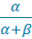  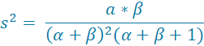 | beta.inv(rand(),alpha, beta)
Dirichlet | 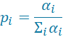 | gamma.inv(rand(),
Gamma | = | gamma.inv(rand(),alpha, beta)

References
Bahl, A., Oudard, S., Tombal, B., Özgüroğlu, M., Hansen, S., Kocak, I., Gravis, G., Devin, J., Shen, L., De Bono, J. S., & Sartor, A. O. (2013). Impact of Cabazitaxel on 2-year survival and palliation of tumour-related pain in men with metastatic castration-resistant prostate cancer treated in the TROPIC trial. Annals of Oncology, 24(9), 2402–2408. https://doi.org/10.1093/annonc/mdt194
Bahl, A., Masson, S., Birtle, A., Dean, E., Kingsmore, D., Jones, R., & on behalf of the UK Cabazitaxel Early Access Programme Investigators. (2015). Second-line treatment for metastatic castration-resistant prostate cancer: Early results from the UK Cabazitaxel Early Access Programme (EAP). BJU International, 116(6), 880–887. https://doi.org/10.1111/bju.13166
Cancer Research UK. (2023). Prostate cancer statistics. https://www.cancerresearchuk.org/health-professional/cancer-statistics/statistics-by-cancer-type/prostate-cancer
Cornford, P., van den Bergh, R. C. N., Briers, E., Van den Broeck, T., Cumberbatch, M. G., De Santis, M., Fanti, S., Fossati, N., Gandaglia, G., Gillessen, S., Grummet, J., Henry, A. M., Lam, T. B., Mason, M. D., Matveev, V. B., Mottet, N., van der Poel, H. G., Rouvière, O., Schoots, I. G., … Mottet, N. (2021). EAU-EANM-ESTRO-ESUR-SIOG guidelines on prostate cancer. European Urology, 79(2), 243–262. https://doi.org/10.1016/j.eururo.2020.09.042
De Bono, J. S., Oudard, S., Ozguroglu, M., Hansen, S., Machiels, J.-P., Kocak, I., Gravis, G., Bodrogi, I., Mackenzie, M. J., Shen, L., Roessner, M., Gupta, S., & Sartor, A. O. (2010). Prednisone plus Cabazitaxel or Mitoxantrone for metastatic castration-resistant prostate cancer progressing after docetaxel treatment: A randomised open-label trial. The Lancet, 376(9747), 1147–1154. https://doi.org/10.1016/S0140-6736(10)61389-X
Department of Health and Social Care. (2024). Drugs and pharmaceutical electronic market information tool (eMIT). https://www.gov.uk/government/publications/drugs-and-pharmaceutical-electronic-market-information-emit
Dolan, P., Gudex, C., Kind, P., & Williams, A. (1995). A social tariff for EuroQol: Results from a UK general population survey (Discussion Paper 138). Centre for Health Economics, University of York.
Drummond, M. F., Sculpher, M. J., Torrance, G. W., O'Brien, B. J., & Stoddart, G. L. (2005). Methods for the economic evaluation of health care programmes (3rd ed.). Oxford University Press. https://doi.org/10.1093/oso/9780198529446.001.0001
Drummond, M. F., Sculpher, M. J., Claxton, K., Stoddart, G. L., & Torrance, G. W. (2015). Methods for the economic evaluation of health care programmes (4th ed.). Oxford University Press.
Hoyle, M. W., & Henley, W. (2011). Improved curve fits to summary survival data: Application to economic evaluation of health technologies. BMC Medical Research Methodology, 11(139). https://doi.org/10.1186/1471-2288-11-139
James, N. D., Tannock, I., N'Dow, J., Feng, F., Garg, T., Goh, J. C., Hamdy, F. C., Haustermans, K., Kenfield, S. A., Mason, M. D., Mazhar, D., Murthy, V., Reiter, R. E., Stattin, P., Tombal, B., Touijer, K. A., van den Bergh, R. C. N., & Agarwal, N. (2024). The Lancet Commission on prostate cancer: Planning for the surge in cases. The Lancet, 403(10437), 1683–1722. https://doi.org/10.1016/S0140-6736(24)00651-2
National Institute for Health and Care Excellence. (2012). Comments on the appraisal consultation document received from the public: Abiraterone for castration-resistant metastatic prostate cancer previously treated with a docetaxel-containing regimen (TA259). https://www.nice.org.uk/guidance/ta259/documents/comments-on-the-appraisal-consultation-document-received-from-the-public-through-the-nice-website2
National Institute for Health and Care Excellence. (2013). Guide to the methods of technology appraisal 2013 (PMG9). https://www.nice.org.uk/process/pmg9
National Institute for Health and Care Excellence. (2016a). Cabazitaxel for hormone-relapsed metastatic prostate cancer treated with docetaxel (TA391). https://www.nice.org.uk/guidance/ta391
National Institute for Health and Care Excellence. (2016b). Cabazitaxel for hormone-relapsed metastatic prostate cancer treated with docetaxel (TA391): Committee papers. https://www.nice.org.uk/guidance/ta391/documents/committee-papers
National Institute for Health and Care Excellence. (2023). NICE health technology evaluations: The manual. https://www.nice.org.uk/process/pmg36
NICE submission (2024). Relugolix for hormone-sensitive prostate cancer (NICE TA995). https://www.cheshireformulary.nhs.uk
Personal Social Services Research Unit (University of Kent) & Centre for Health Economics (University of York). (n.d.). Unit Costs of Health and Social Care 2024 Manual - Kent Academic Repository. https://kar.kent.ac.uk/109563/
Talbot, T., Dangoor, A., Shah, R., Naik, J., Talbot, D., Lester, J. F., Cipelli, R., Hodgson, M., Patel, A., Summerhayes, M., & Newsom-Davis, T. (2017). The burden of neutropenic sepsis in patients with advanced non-small cell lung cancer treated with single-agent docetaxel: A retrospective study. Lung Cancer, 113, 115-120. https://doi.org/10.1016/j.lungcan.2017.09.014

